Name:

Unit 7 Pick Three
Directions: From the following nine boxes, you must pick THREE activities to complete. When you pick your three activities, all three must be in a row, like tic-tac-toe!

Make three of your own one step inequality word problems. Solve each problem. Be sure to show all your work!  Inequality ex. (x < 4) | Design your own pattern. The pattern must continue to grow for at least 5 steps. At the end, explain what your pattern was doing. | Research your favorite college basketball player and graph how many points that player had for each game in February. They MUST NOT be injured. Be sure to label your graph with each axis and title it.
Sketch three different graphs and describe what each of their scenarios are. For example: walking to school, driving to school, or ride bike to school. You would sketch a graph of the time it took to get to school with the scenario below it. | Compare three of your favorite sodas or juice. Take the nutrition label and compare the sugar per fluid ounces. At the end, write a paragraph about which drink is the most healthy to drink and why. | Design a budget plan using the spreadsheet provided for you to make a grocery list. You can only spend $100 and need to list each item and the cost. Make sure you total everything up at the end. ALL ITEMS MUST BE SCHOOL APPROPIATE.
Research the price of 3 items of your choice and decide which item has the better buy. | Make a foldable to help you remember how to graph inequalities. Be specific with the directions like you are the teacher. | Make a song about how to read spreadsheets and how they can be helpful. Use examples of how you can use them in in real life.

Inequality Word Problems
Directions: Make three of your own one step inequality word problems. Solve each problem. Be sure to show all your work! Inequality ex. (2x < 4 or x < 2)

Word Problem #1:

How to solve (show work):

Word Problem #3:

How to solve (show work):
Word Problem #2:

How to solve (show work):

Designing Pattern
Directions: Design your own pattern. The pattern must continue to grow for at least 5 steps. At the end, explain what your pattern was doing.

Step #1: Step #2

Step #3: Step #4:

Step #5:
Explanation of Pattern:

College Basketball Player Stats
Directions: Research your favorite college basketball player and graph how many points that player had for each game in February. They MUST NOT be injured. Be sure to label your graph with each axis and title it.

Player Chosen:

Team they play for:

Points scored each game:

Sketch Graph
Directions: Sketch three different graphs and describe what each of their scenarios are. For example: walking to school, driving to school, or ride bike to school. You would sketch a graph of the time it took to get to school with the scenario below it.

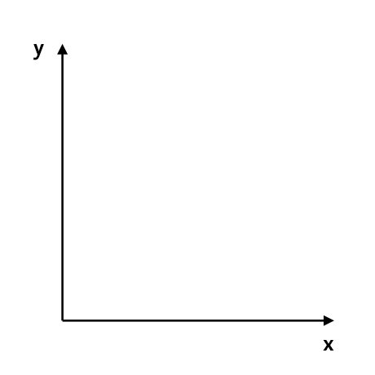

Graph Scenario #1: Graph Scenario #2:

Graph Scenario #3:

Soda Comparison
Directions: Compare three of your favorite sodas or juice. Take the nutrition label and compare the sugar per fluid ounces. At the end, write a paragraph about which drink is the most healthy to drink and why.

Glue Soda #1 Nutrition Label: Glue Soda #2 Nutrition Label:

Glue Soda #3 Nutrition Label: Paragraph of which one is healthier
and why?

Budget Plan
Directions: Design a budget plan using the spreadsheet provided for you to make a grocery list. You can only spend $100 and need to list each item and the cost. Make sure you total everything up at the end. ALL ITEMS MUST BE SCHOOL APPROPIATE.

Item | Cost
Total

Unit Price of Three Items
Directions: Research the price of 3 items of your choice and decide which item has the better buy.

Item #1: Item #2:

Cost: Cost:

Ounces: Ounces:

Unit Price: Unit Price:

Item #2: Explanation of which one is the better
buy. Why did you choose that option?

Cost:

Ounces:

Price:

Design a Foldable
Directions: Make a foldable to help you remember how to graph inequalities. Be specific with the directions like you are the teacher. Please use construction paper for this that is provided by the teacher. I have an example of a foldable to help you below. You should have greater than, less than, greater than or equal to, and less than or equal to in your foldable! Do not just copy! Make it your own!

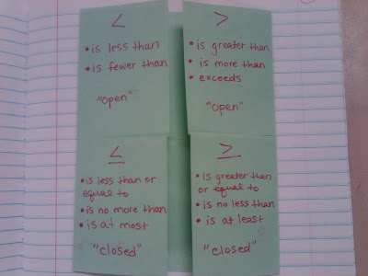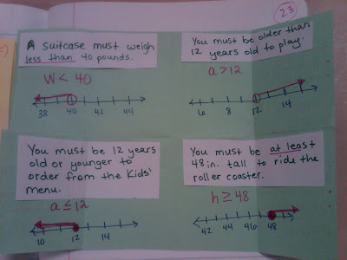

NOTES FOR YOUR FOLDABLE:

Make a Song
Directions: Make a song about how to read spreadsheets and how they can be helpful. Use examples of how you can use them in in real life.

Song Lyrics:

